 

**Placement Empowerment Program**

**Cloud Computing and DevOps Centre**

**Set Up a Cloud-Based Monitoring Service**

**“*Create a free-tier AWS, Azure, or GCP account. Launch a virtual machine and SSH into it.*”**

Name: **DHARSHINI P** DEPARTMENT: **IT**



**Introduction**

In cloud environments, monitoring is essential to track system performance, optimize resources, and ensure application reliability. Cloud-based monitoring services provide real-time insights into key metrics like CPU usage, memory consumption, disk I/O, and network traffic. This helps administrators proactively detect and resolve performance issues before they impact users.

**Overview**

Cloud-based monitoring tools, such as **AWS CloudWatch, Azure Monitor, and Google Cloud Operations Suite**, collect, analyze, and display system performance metrics. These tools enable logging, alerting, and automated responses to maintain cloud infrastructure efficiency

**Objective**

**The primary objectives of this POC are:**

* Enable a basic cloud monitoring service (e.g., AWS CloudWatch).
* View and analyze metrics such as CPU usage, disk I/O, and network performance.
* Set up alerts and dashboards for real-time monitoring.
* Ensure system reliability and quick issue resolution.

**Important**

* **Proactive Issue Detection** – Identify and fix performance issues before they affect end users.
* **Cost Optimization** – Detect underutilized resources to reduce unnecessary cloud spending.
* **Improved Security** – Monitor suspicious activity and set alerts for unusual spikes in usage.
* **Performance Optimization** – Ensure applications are running efficiently with real-time insights.
* **Automated Response** – Automatically trigger actions (e.g., auto-scaling, restarting instances) when thresholds are exceeded

**Step-by-Step Overview**

**Step 1:**

**Choose a Cloud Monitoring Service**

* AWS: CloudWatch
* Azure: Azure Monitor
* Google Cloud: Cloud Operations Suite

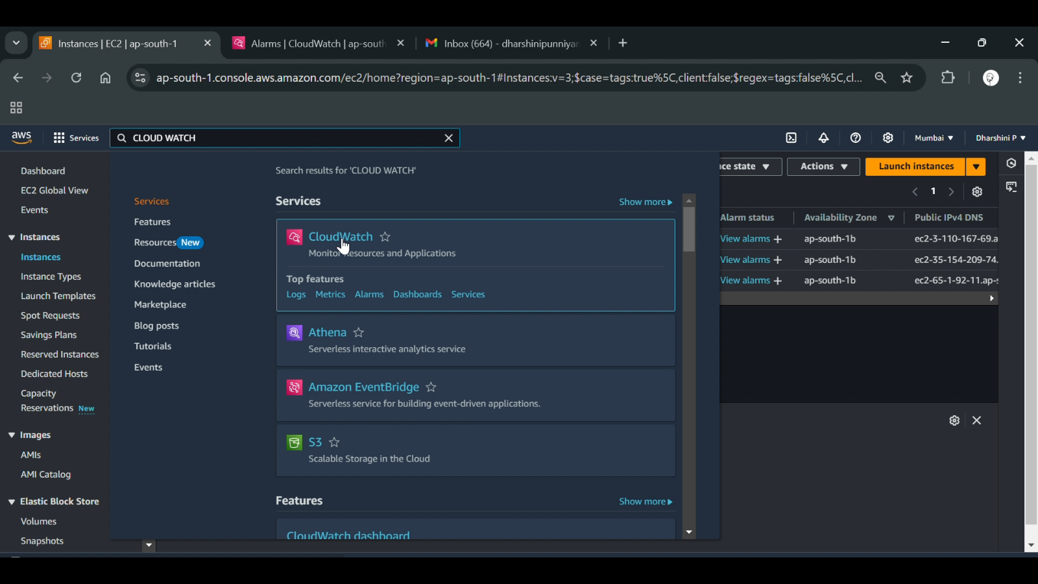

**Step 2:**

**Enable Monitoring for Your Cloud VM**

* AWS: Ensure CloudWatch Agent is installed and configured on the EC2 instance.

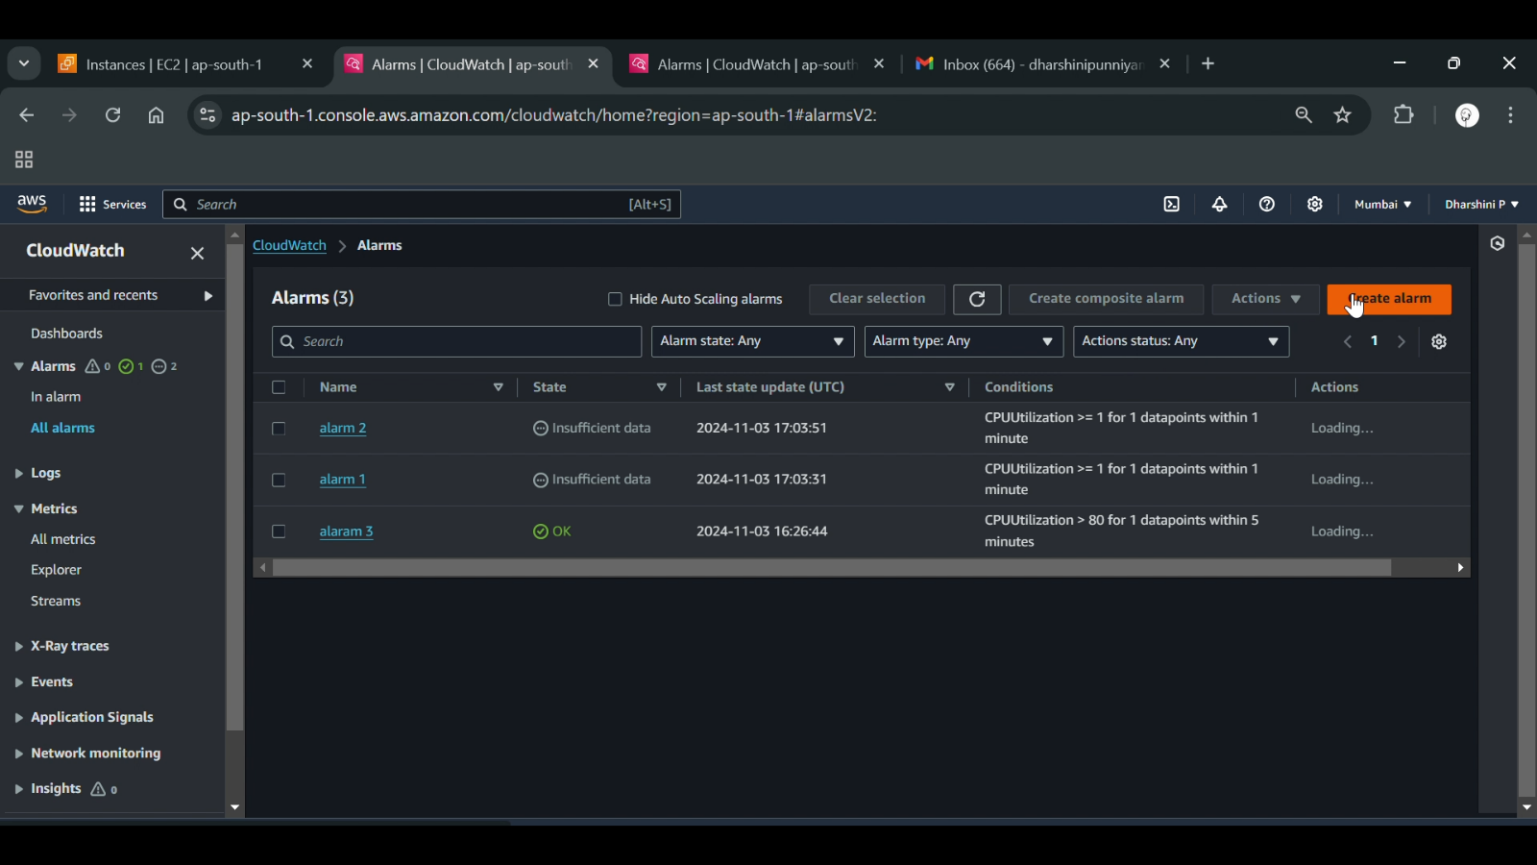

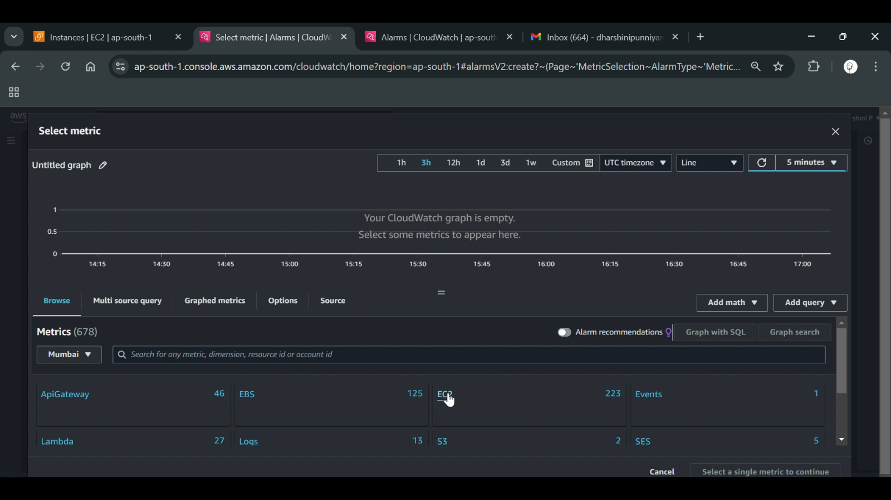

**Step 3:**

**View Basic Metrics**

* CPU utilization
* Disk read/write operations (I/O)
* Memory usage
* Network traffic (inbound/outbound data)

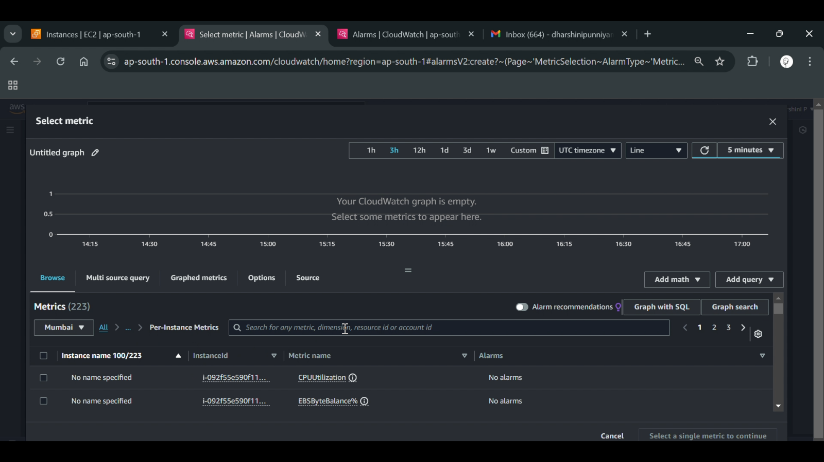

**Step 4:**

**Configure CloudWatch (or Equivalent) Dashboards**

* Create a custom dashboard to display key performance metrics.
* Add widgets for CPU, disk, and network usage graphs.

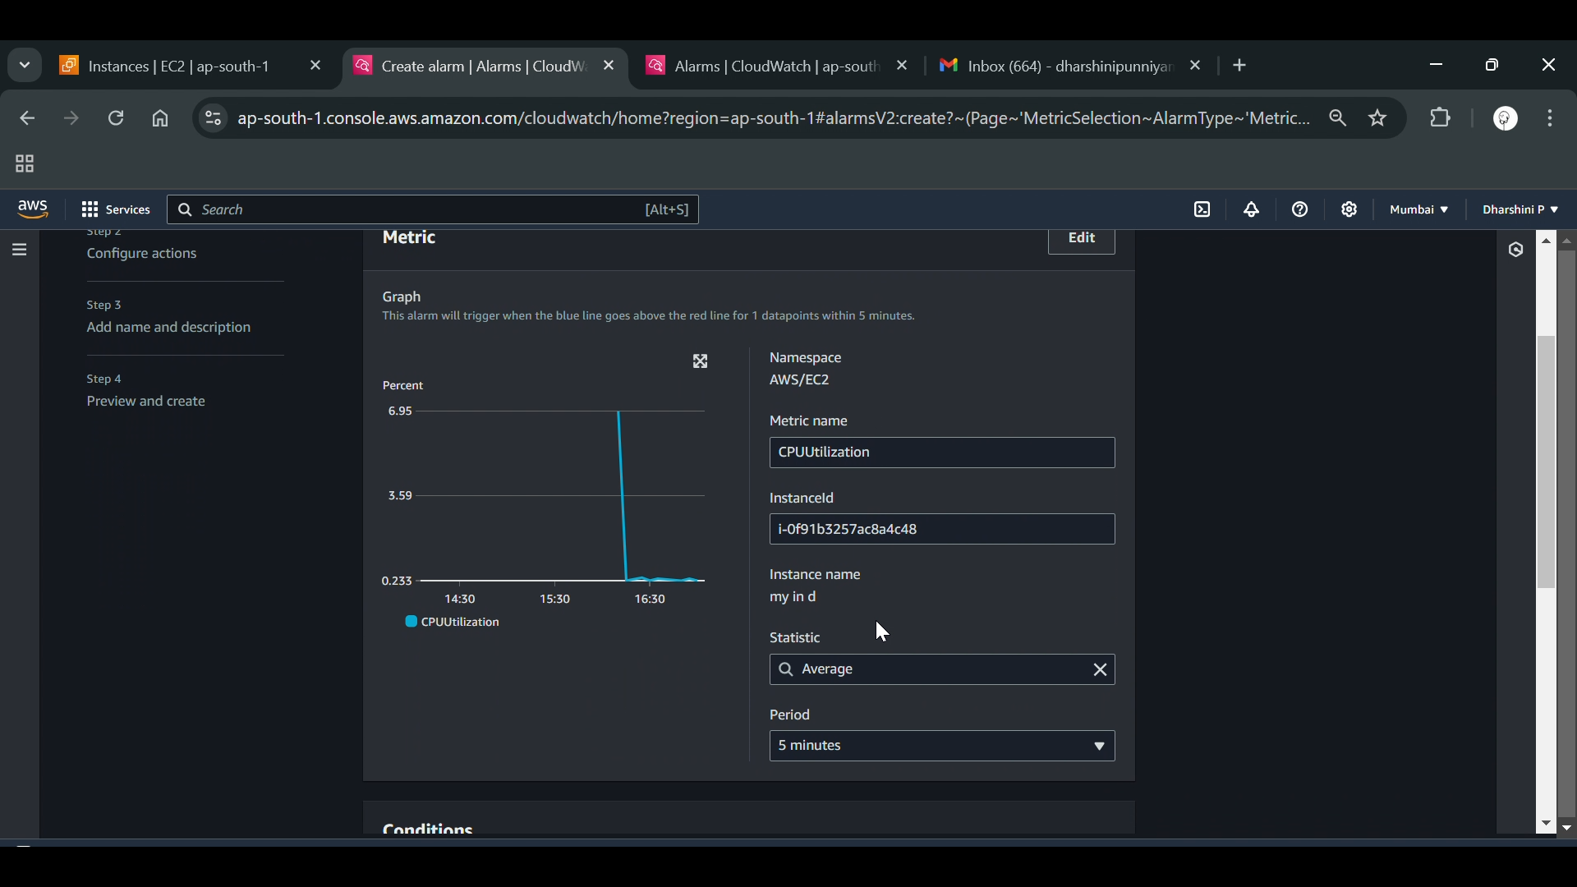

**Step 5:**

**Set Up Alerts for Critical Metrics**

* Define threshold limits (e.g., trigger an alert if CPU usage exceeds 80%).
* Configure email/SMS notifications via Amazon SNS, Azure Action Groups, or Google Cloud Alerting.

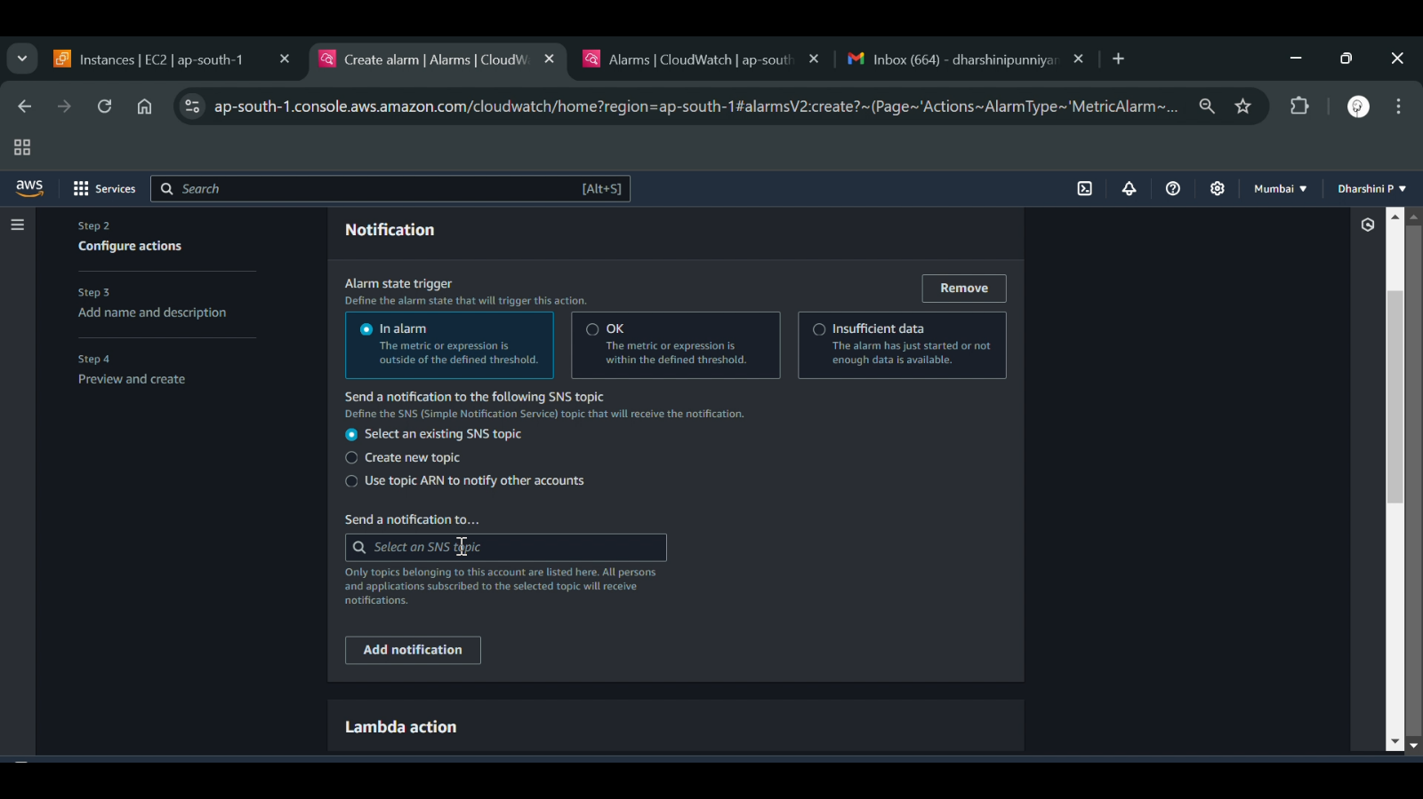

**Step 6:**

**Automate Responses (Optional but Recommended)**

* Set up auto-scaling based on CPU/memory usage.
* Restart instances automatically when high memory consumption is detected.

**Expected Outcome:**

By the end of this process, you will have:

* **Real-time monitoring** of cloud resources with detailed performance insights.
* **Automated alerts** for quick issue detection and resolution.
* **Optimized resource utilization** for cost efficiency.
* **Enhanced security** by tracking unusual activity patterns.